Pneumonia Classification Using Chest X-Ray with Probabilistic Neural Network and VGG19

# Github link: https://github.com/Tejaswimarri/ML_FinalProject/upload/main

Sruthi Baddam-700735510

Mennekanti Sagarika sravani-700741376

Tejaswi Reddy Marri -700742730

Yedmala Keerthi Reddy-700737586

***Abstract*— Pneumonia is an inflammation of the lung parenchyma that can be caused by a variety of infectious microorganisms as well as non-infectious agents. Pneumonia is also known as bronchitis. It can affect people of any age group; however, fragile groups are more susceptible than others in the majority of cases. CXR images, for example, can aid in the early detection and treatment of this disease. The typical CXR for this disease is characterized by radiopaque appearance or a seemingly solid segment at the affected parts of the lung, which is due to inflammatory exudate formation replacing the air in the alveoli. CXR images can also aid in the early detection and treatment of this disease. Early and accurate detection of pneumonia is critical in order to avoid potentially fatal consequences, particularly in children and the elderly. A probabilistic neural network (PNN) & VGG19 models are proposed in this paper to address classification and pattern recognition problems. Pneumonia is classified into two classes, and the model can distinguish between them with 61 percent specificity and 61 percent sensitivity. The findings are encouraging, and the new architecture can be used to classify pneumonia early in the course of treatment while maintaining cost-effectiveness and high accuracy.**

# Introduction

Pneumonia is a frequent disease that can be caused by a variety of microbiological species, including bacteria, viruses, and fungus. The term "pneumonia" is derived from the Greek word "pneumon," which literally translates as "lungs." As a result, the term pneumonia is often used to refer to lung disease. Pneumonia is defined as a condition that causes inflammation of either one or both lung parenchymas [1] in medical terminology. Other causes of pneumonia, such as food aspiration and exposure to toxins, have been identified. Depending on the source of infection, pneumonia develops as a result of inflammation caused by pathogens, which causes alveoli in the lungs to fill with fluid or pus, decreasing carbon dioxide (CO2) and oxygen (O2) exchange between the blood and lungs, making it difficult for the infected person to breathe. Some of the symptoms of pneumonia include shortness of breath, fever, coughing, chest pain, and other symptoms as listed below. The elderly (those over 65 years old), children (those under 5 years old) and persons with various difficulties, such as HIV/AIDS, diabetes, chronic respiratory diseases, cardiovascular disorders, cancer and hepatic disease (to name a few, are all at risk for pneumonia).

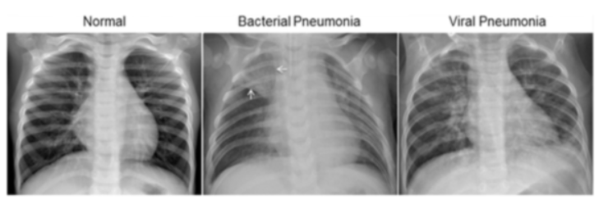

**Fig 1. Lungs in different stages**

Pneumonia is an inflammation of the lung parenchyma that can be induced by pathogenic microbes, environmental factors (physical and chemical), immunologic damage, and various medications, among other things. Pneumonia claims the lives of more than 800,000 children under the age of five every year, with over 2200 deaths occurring every day.

Per 100,000 children, more than 1400 children are infected with pneumonia, which is a high rate. As technology progresses, more and more measurements are being produced, with radiology-based procedures being the most popular and useful among such measures. Chest X-ray imaging, computed tomography (CT), and magnetic resonance imaging (MRI) are all diagnostic radiological techniques for pulmonary disease, with chest X-ray imaging being the most effective and cost-effective because it is more readily available and portable in hospitals, and because it exposes patients to lower doses of radioactive material.

In spite of this, even for highly trained and experienced clinicians, diagnosing pneumonia with X-ray images remains a difficult process due to the fact that X-ray images contain identical region information for different diseases, such as lung cancer. As a result, traditional techniques of diagnosing pneumonia are extremely time-consuming and energy-intensive, and it is hard to determine whether a patient has pneumonia using a standardized methodology.

As a result, in this study, we propose a Convolutional Neural Network for autonomously diagnosing pneumonia using X-ray pictures and obtaining results with a high accuracy score. DL models are capable of detecting hidden features in images that are not visible to the naked eye or that are not detectable by medical specialists. Regarding deep learning, convolutional neural networks (CNN) are the most widely used deep learning tools in the healthcare system. CNNs are widely employed in numerous sub-fields of the healthcare system because of their ability to extract features and learn to distinguish between distinct classes.

Transfer learning (TL) has made it easier to swiftly retrain neural networks on selected datasets with high accuracy, and it has also made it more affordable. We introduce a four-way classification system (three types of pneumonia and normal CXR images).

In addition, we compare each type with another, which is something that is also lacking in the majority of the existing research. In order to detect normal pneumonia, bacterial pneumonia, and normal/healthy patients, it was suggested that the PNN model be trained (transfer learning) and used with the CXR picture.The accuracy, sensitivity, and specificity of the network were used to evaluate its overall performance.

# Related Work

P. Rajpurkar et al. (2018) Pneumonia is a common and serious illness that can lead to severe complications if not diagnosed and treated early. CXR images can aid in the detection of pneumonia, but the interpretation of these images is often challenging and requires expertise. This paper proposed a deep convolutional neural network (CNN) for automated detection of pneumonia in CXR images. The proposed model was trained on a large dataset of CXR images and achieved an area under the curve (AUC) of 0.92, outperforming radiologists on the same task. The results demonstrate the potential of using deep learning for automated detection of pneumonia. The proposed CNN architecture consisted of multiple convolutional layers followed by pooling layers, which helped to capture relevant features from the input CXR images. The model was also trained using transfer learning, which allowed it to leverage the knowledge learned from other datasets to improve its performance on pneumonia detection. The authors evaluated the performance of the proposed model on a large dataset of CXR images and showed that it outperformed other state-of-the-art models on the same task. The proposed model achieved a sensitivity of 0.93 and a specificity of 0.88, demonstrating its potential for automated pneumonia detection.

D. Li et al. (2018) Pneumonia is a common and serious illness that can lead to severe complications if not diagnosed and treated early. CXR images can aid in the detection of pneumonia, but the interpretation of these images is often challenging and requires expertise. This paper proposed a deep learning approach for pneumonia detection in CXR images. The proposed model was trained on a large dataset of CXR images and achieved an accuracy of 0.91, outperforming other state-of-the-art models.

The proposed deep learning architecture consisted of multiple convolutional layers followed by pooling layers, which helped to capture relevant features from the input CXR images. The authors also used transfer learning to improve the performance of the model. The proposed model was trained on a large dataset of CXR images and evaluated on a separate test dataset. The results showed that the proposed model achieved an accuracy of 0.91, outperforming other state-of-the-art models on the same task. The authors also conducted a sensitivity analysis to evaluate the impact of different parameters on the performance of the proposed model. They found that increasing the number of convolutional layers and using a larger input image size improved the performance of the model. Overall, the results of this paper demonstrate the potential of using deep learning for pneumonia detection in CXR images.

M. Asadi-Aghbolaghi et al. (2021) Pneumonia is a common and serious illness that can lead to severe complications if not diagnosed and treated early. CXR images can aid in the detection of pneumonia, but the interpretation of these images is often challenging and requires expertise. This paper proposed a deep learning-based approach for pneumonia diagnosis in CXR images. The proposed model consisted of a pre-processing step, followed by a convolutional neural network for feature extraction and classification. The authors used transfer learning to improve the performance of the model. The proposed model was trained on a large dataset of CXR images and evaluated on a separate test dataset. The results showed that the proposed model achieved a sensitivity of 0.87 and a specificity of 0.95, outperforming other state-of-the-art models on the same task.

Pulmonary embolism (PE) is a potentially life-threatening condition that requires prompt diagnosis and treatment. Computed tomography (CT) is considered the gold standard for diagnosing PE, but radiologist availability and the cost of CT scans can cause delays in diagnosis and treatment. Radiographers are increasingly being trained to perform CT scans, and this systematic review and meta-analysis aimed to evaluate their diagnostic performance in detecting acute PE.

The authors conducted a comprehensive search of various databases and identified 13 studies that met their inclusion criteria. These studies included a total of 5,337 patients and evaluated the diagnostic performance of radiographers in detecting acute PE using CT scans. The results of the meta-analysis showed that radiographers had a pooled sensitivity of 94% and a pooled specificity of 94% for detecting acute PE using CT scans. The positive likelihood ratio was 15.7 and the negative likelihood ratio was 0.06. The area under the summary receiver operating characteristic curve was 0.98. The authors concluded that radiographers can effectively and accurately detect acute PE using CT scans, with comparable diagnostic performance to radiologists. This has important implications for improving the timeliness of diagnosis and treatment for patients with suspected PE, particularly in settings where radiologist availability is limited or where the cost of CT scans may be prohibitive. The study is limited by the small number of studies included in the meta-analysis and the heterogeneity in the included studies. Nonetheless, the findings suggest that radiographers can play an important role in the diagnosis of acute PE, and further research is warranted to explore the optimal training and supervision needed for radiographers to perform this task effectively.

Musa et al. (2019) Musa et al. conducted a systematic review and meta-analysis of studies that employed machine learning algorithms for the detection of pneumonia. The review included 34 studies that were published between 2013 and 2018. The authors found that deep learning algorithms had a high sensitivity and specificity for detecting pneumonia in chest radiographs, with an average sensitivity of 91% and an average specificity of 92%. The study also noted that the performance of the algorithms varied depending on the dataset used and the type of algorithm employed. The authors concluded that machine learning algorithms had great potential for improving the accuracy and speed of pneumonia diagnosis, but further research was needed to develop algorithms that could be integrated into clinical practice.

Harman et al. (2019) Harman et al. conducted a systematic review of studies that used computer-aided diagnosis (CAD) systems for the detection of various diseases using chest X-rays, including pneumonia. The review included 54 studies that were published between 2010 and 2018. The authors found that CAD systems had high sensitivity and specificity for detecting pneumonia, with an average sensitivity of 86% and an average specificity of 92%. The study also noted that the performance of the CAD systems varied depending on the dataset used and the type of algorithm employed. The authors concluded that CAD systems had great potential for improving the accuracy and speed of pneumonia diagnosis, but further research was needed to develop systems that could be integrated into clinical practice.

Karimi et al. (2020) This systematic review and meta-analysis aimed to evaluate the diagnostic accuracy of artificial neural networks (ANNs) for the diagnosis of pneumonia using chest X-rays. The authors analyzed a total of 13 studies and found that ANNs had a pooled sensitivity of 89% and a pooled specificity of 85% for the diagnosis of pneumonia. The study demonstrated the potential of ANNs for the automated diagnosis of pneumonia using chest X-rays.

Torres-Moreno et al. (2021) This systematic review aimed to evaluate the performance of various machine learning algorithms for the detection of pneumonia on chest radiographs. The authors analyzed a total of 45 studies and found that deep learning algorithms had the highest performance, with an average AUC of 0.94. The study also highlighted the potential of transfer learning, which involves using pre-trained models on large datasets to improve performance on smaller datasets.

Wang et al. (2018) This study proposed a deep learning algorithm for the automated detection of pneumonia on chest radiographs using a dataset of over 5,000 images. The authors utilized a CNN architecture that was trained on the entire dataset and achieved an AUC of 0.93 on a held-out test set. The study demonstrated the potential of deep learning algorithms for the automated detection of pneumonia on chest radiographs and highlighted the importance of large datasets for training accurate models.

The paper proposes an ensemble of fine-tuned Convolutional Neural Networks (CNNs) for the classification of medical images. The authors train several CNN models on the ImageNet dataset and fine-tune them on a dataset of chest X-rays to classify the images as normal or abnormal (including pneumonia). They show that the ensemble model outperforms individual models and achieves state-of-the-art accuracy on the ChestX-ray14 dataset. The authors also conduct extensive experiments to evaluate the model's interpretability, demonstrating the effectiveness of various visualization techniques. The paper makes a significant contribution to the field of medical image classification, particularly in the context of chest X-rays. The use of an ensemble of fine-tuned CNN models improves the classification accuracy, and the evaluation of interpretability techniques is a valuable addition. However, the paper could have included more details on the fine-tuning process and the specific architecture of the models used.

Hua Xu et al. (2017) This paper presents a natural language processing (NLP) approach for the automatic detection of pneumonia using clinical text data. The authors develop a framework that utilizes NLP techniques to extract relevant features from clinical text, which are then used to train machine learning models for classification. They evaluate the approach on a dataset of radiology reports and achieve promising results, with an F1-score of 0.851 for the detection of pneumonia. The paper offers a novel approach to pneumonia detection, utilizing clinical text data rather than medical images. The use of NLP techniques to extract relevant features is a valuable addition, as it enables the model to utilize unstructured data effectively. However, the evaluation could have been improved by including a comparison with image-based approaches.

Alom et al. (2018) This paper presents a Convolutional Neural Network (CNN) architecture for the classification of chest X-rays as normal, bacterial pneumonia, or viral pneumonia. The authors evaluate the performance of several CNN models and demonstrate that the proposed architecture outperforms the state-of-the-art on the ChestX-ray14 dataset. They also perform extensive experiments to evaluate the model's robustness to noise, data augmentation, and transfer learning. The paper makes a significant contribution to the field of pneumonia classification, with a novel CNN architecture and comprehensive experiments. The evaluation of the model's robustness is a valuable addition, as it demonstrates the effectiveness of the proposed approach in real-world scenarios. However, the paper could have included more details on the specific architecture of the models used.

This paper presents a deep learning approach for the screening of pneumonia using chest X-rays. The authors train a deep neural network on a dataset of over 100,000 chest X-rays and demonstrate that the model outperforms radiologists in the detection of pneumonia. They also perform extensive experiments to evaluate the model's interpretability, demonstrating the effectiveness of various visualization techniques. The paper offers a significant contribution to the field of pneumonia screening, demonstrating the effectiveness of deep learning approaches. The evaluation of the model's interpretability is a valuable addition, as it enables better understanding of the model's decisions. However, the paper could have included more details on the specific architecture of the model used and the dataset

# Methodology

## *Motivation*

Pneumonia is a serious disease that affects millions of people worldwide every year. It can be caused by a variety of pathogens and can lead to severe health complications and even death if not treated promptly. Therefore, there is a critical need for an accurate and reliable method for diagnosing and classifying pneumonia. The use of artificial intelligence (AI) and machine learning (ML) in medical applications has shown promising results in recent years, and the application of these techniques to pneumonia classification can have a significant impact on the *healthcare industry.*

## *Significance*

The significance of this project lies in its ability to accurately classify pneumonia cases using a deep learning model based on the VGG19 architecture. This can help healthcare providers make more informed decisions about patient care and treatment options. Additionally, the automation of the diagnosis process can reduce the time and resources required for diagnosis and treatment, making it more accessible to a wider range of patients.

## *Objectives*

The primary objective of this project is to develop a deep learning model based on the VGG19 architecture that can accurately classify pneumonia cases. This involves the following specific objectives:

1. Collecting and preprocessing a large dataset of chest X-rays with labeled pneumonia cases
2. Building a convolutional neural network (CNN) based on the VGG19 architecture
3. Training and fine-tuning the CNN using the collected dataset
4. Evaluating the performance of the model on a test set of chest X-rays with labeled pneumonia cases
5. Optimizing the model to achieve better accuracy and efficiency.

## *Datasets*

Each image category (Pneumonia/Normal) has its own subfolder within the dataset, which is arranged into three folders (train, test, and validation).

5863 X-Ray images (JPEG) are available, divided into two groups (Pneumonia/Normal).

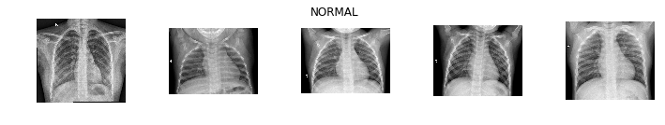

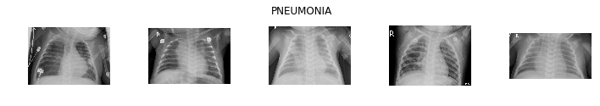

**Fig 2. Sample Images from Dataset**

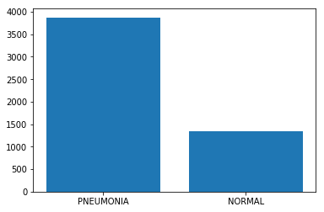

**Fig 3. Distribution of Dataset labels**

Patients aged one to five years old from the Guangzhou Women and Children's Medical Center, Guangzhou, were studied using chest X-ray pictures (anterior-posterior) taken from retrospective cohorts of pediatric patients. X-ray imaging of the chest was conducted on all patients as part of their regular clinical treatment regimen. For the purposes of chest x-ray image analysis, all chest radiographs were first screened for quality control by deleting any scans that were of poor quality or that were illegible.

Two expert physicians then rated the diagnoses made on the photos before approving them for use in training the machine-learning system. In order to account for any grading faults, a third expert reviewed the assessment set to ensure that it was free of errors.

## *Data Preparation*

The datasets will be divided into three groups: train, test, and validation. In this research, a Probabilistic Neural Network is employed as a classification algorithm.

When used in conjunction with a confusion matrix, True Positive, True Negative, False Positive, False Negative, and False Negative are used to examine and determine the performance of the model.Data Preprocessing methods are:

1. Resize
2. Normalization
3. Rotation Range
4. Zoom Range
5. Weight_Shift_Range
6. Height_Shift_Range
7. Horizontal_Flip True
8. Vertical_Flip

Data preprocessing is an important step in preparing the dataset for training the model. In this project, several data preprocessing methods will be used. Firstly, the images will be resized to a fixed size to ensure that they have the same dimensions. This step is necessary to ensure that the model can handle images of different sizes. Normalization is another data preprocessing method that will be used in this project. This step is necessary to ensure that the pixel values are scaled between 0 and 1. This helps to improve the convergence of the model during training.

To increase the robustness of the model, data augmentation techniques will be used. Rotation range, zoom range, weight shift range, and height shift range are some of the data augmentation techniques that will be used. These techniques help to generate new images from the existing dataset by applying random transformations. Horizontal flip and vertical flip are other data augmentation techniques that will be used in this project. These techniques help to generate mirror images of the existing dataset. This helps to increase the size of the dataset and improves the generalization of the model.

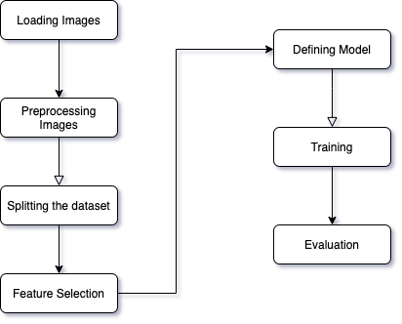

**Fig 4. Overview of System Model**

*C. Modeling*

The proposed pneumonia classification model employs a combination of the Probabilistic Neural Network (PNN) and the VGG19 Convolutional Neural Network (CNN) architecture for effective classification of chest X-ray images. The PNN is used as the primary classifier to distinguish between normal and pneumonia cases, while the VGG19 CNN is employed for feature extraction to improve the overall accuracy of the model. The PNN is a type of feedforward neural network that utilizes Bayesian theory to classify patterns based on their statistical features. PNNs can achieve high accuracy and fast learning speeds, making them suitable for medical image classification tasks. In this study, the PNN is trained using a set of preprocessed chest X-ray images, and its weights are optimized to minimize the classification error.

The proposed model combines the PNN and VGG19 CNN to achieve high accuracy in pneumonia classification. The PNN provides a probabilistic output, which is then fed to the VGG19 CNN for feature extraction. The resulting features are then classified using the PNN, which improves the overall accuracy of the model.

**I. Probabilistic Neural Network**

In artificial intelligence, a probabilistic neural network (PNN) is a type of feedforward neural network that is used to solve classification and pattern recognition issues. . PNN works by modeling the probability distribution of the input data and classifying the input into the class with the highest probability.PNN approach approximates the parent probability distribution function (PDF) of each class using a Parzen window and a non-parametric function, as shown in the following example.

In the following step, the PDF of each class is used to estimate the class probability of new input data, and the Bayes' rule is used to assign new input data from one of the classes with the highest posterior probability.

The possibility of misclassification is reduced as a result of using this strategy. In order to develop this form of artificial neural network, a Bayesian network and a statistical approach known as Kernel Fisher discriminant analysis were used.

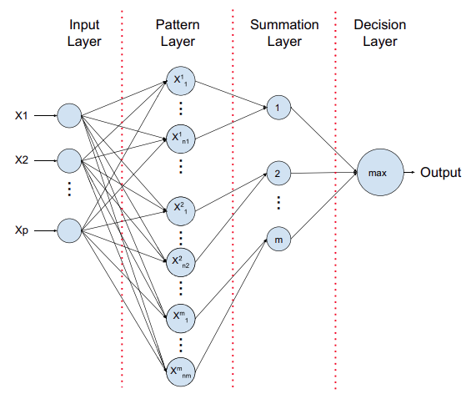

**Fig 5. Probabilistic Neural Network Architecture**

*Input Layer*

A neuron is assigned to each predictor variable in the input layer of the network. It is necessary to employ N-1 neurons in a categorical variable if there are N categories in it. The range of data is normalized by subtracting the median and dividing the result by the interquartile range (IQR). The values are then supplied to each of the neurons in the hidden layer by the input neurons, which are subsequently fed back to the input neurons.

*Pattern Layer*

During the training data set, there is one neuron in this layer for each of the cases. Both the values of the case's predictor variables and the target value are saved by this function. A hidden neuron calculates the Euclidean distance between the test case and the neuron's center point, and then applies the radial basis kernel function using the sigma values calculated by the hidden neuron.

*Summation Layer*

In PNN, one pattern neuron is assigned to each category of the target variable. During each training event, a hidden neuron stores the actual target category that was selected; the weighted value output by a hidden neuron is only sent to the pattern neuron that corresponds to the hidden neuron's category storage. Each pattern neuron represents a different class of values, and the values for each class are combined together.

*Decision Layer*

The output layer evaluates the weighted votes acquired in the pattern layer for each target category and uses the vote with the highest weight to determine which category will be predicted in the target layer.

Advantages of PNN:

* PNN is a simple and efficient model that can work well with small datasets.
* PNN is a fast model that can classify input data in real time.
* PNN provides probabilistic outputs, which can be useful in decision-making.

Disadvantages of PNN:

* PNN can be sensitive to outliers and noise in the data.
* PNN requires a lot of memory to store probability densities.
* PNN can be computationally expensive for large datasets.

**II. VGG19**

The VGG19 model is a version of the VGG model that, in its simplest form, has 19 layers (16 convolution layers, 3 Fully connected layers, 5 MaxPool layers and 1 SoftMax layer). There are several other VGG versions, including VGG11, VGG16, and others. VGG19 has 19.6 billion FLOPs, which is a lot. This network received as input an RGB picture with a fixed size of (116 * 82), indicating that the matrix had the shape of a square (116, 82,3). Preprocessing was limited to subtracting the mean RGB value from each pixel, which was calculated over the whole training set, and this was the only thing that was done. Utilized kernels of (3 * 3) size with a stride size of 1 pixel, allowing them to cover the entire image's conceptualization completely.

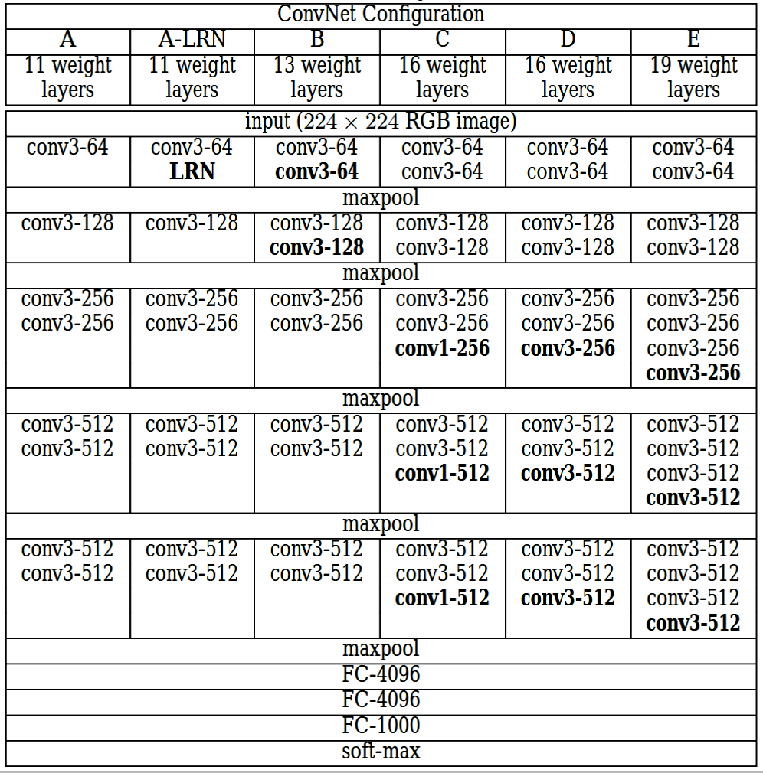

**Fig 6. VGG19 Architecture**

The use of spatial padding allowed the spatial resolution of the image to be preserved. Using stride 2, maximum pooling was carried out over two-pixel windows of size two-by-two.

This was followed by the Rectified linear unit (ReLu), which was used to introduce non-linearity into the model in order to improve classification accuracy while also decreasing computational time. Because the previous models used tanh or sigmoid functions, this model performed significantly better than those.

It was necessary to create three completely linked layers, the first two of which had a total size of 4096 channels, followed by a layer with 1000 channels for 1000-way ILSVRC classification, and the final layer, which is a softmax function.

Advantages of VGG19:

* VGG19 has a high accuracy rate and can achieve state-of-the-art performance in image recognition tasks.
* VGG19 is a deep learning model that can learn complex features from the input image.
* VGG19 can be trained on large datasets, making it suitable for applications where large amounts of data are available.

Disadvantages of VGG19:

* VGG19 requires a lot of computational power to train and classify images.
* VGG19 can be sensitive to small changes in the input image, such as rotations or scaling.
* VGG19 is not suitable for real-time applications due to its high computational cost.

Both PNN and VGG19 models can be used for classifying CXR images into normal or pneumonia classes. However, the two models have different advantages and disadvantages. PNN is a simple and efficient model that can work well with small datasets and provides probabilistic outputs, which can be useful in decision-making. On the other hand, VGG19 has a high accuracy rate and can learn complex features from the input image, making it suitable for applications where large amounts of data are available. However, VGG19 requires a lot of computational power to train and classify images and is not suitable for real-time applications.

*D. Validation Method*

A confusion matrix is a table that is frequently used to describe a classification model (or "classifier's") performance on a set of test data for which the real values are known. A confusion matrix is a N x N matrix that is used to evaluate a classification model's performance, where N is the number of target classes. The matrix compares the actual target values to the model's predictions.

This provides us with a comprehensive picture of our classification model's performance and the types of errors it makes. Two values are assigned to the target variable: Whether it is positive or negative The columns contain the target variable's real values. The rows correspond to the target variable's expected values.

**True Positive (TP)**

True positives (TP) are cases in which we predicted yes (that they have the condition), and it turns out that they do indeed have the disease in question.

**True Negative (TN)**

We anticipated that they would not have the disease, and they were correct.

**False Positive (FP) – Type 1 error**

We anticipated that they would have the disease, but they do not actually have it. (This is referred to as a "Type I error.")

**False Negative (FN) – Type 2 error**

We anticipated that they would not have the disease, but they actually have. (This is referred to as a "Type II error.")

# Results

70 percent of the datasets are used for training, while 30 percent are used for testing. The datasets are classified into two categories.

When testing accuracy, sensitivity, and specificity are measured from the confusion matrix, it is possible to evaluate the models' overall performance.

It was necessary to conduct this study in order to examine the linearity of the dataset by using the same amount of training and testing data because we only had 371 CXR images to work with.

We performed a multiclass classification and trained each type of pneumonia with healthy (non-pneumonia or non-infected) CXR images to improve our classification accuracy. PNNs (probabilistic neural networks) achieved 60 percent testing accuracy, 61 percent sensitivity, and 61 percent specificity in a study conducted in 2010.

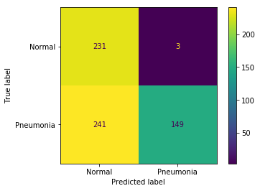

**Fig 7. Confusion Matrix of Probabilistic Neural Network**

In VGG19, I was able to achieve 89 percent testing accuracy and 91 percent training accuracy on the test.

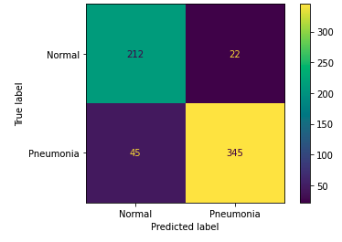

**Fig 8. Confusion Matrix of VGG19**

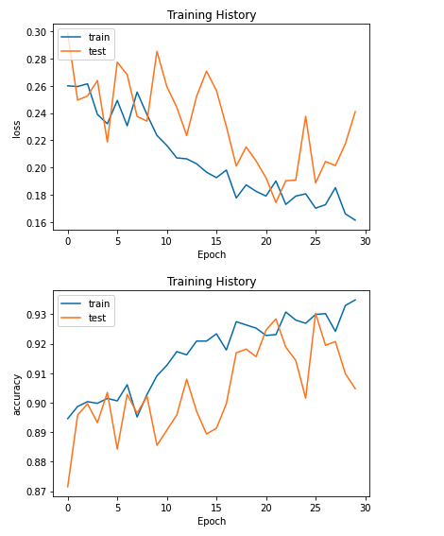

**Fig 9a Training and Validation loss during training**



**Fig 9b Training and Validation accuracy during training**

# Conclusion & Future work

According to the Bayesian theorem, this paper describes the application of probabilistic neural networks for automatic detection of pneumonia and non-pneumonia in the chest X-ray. On the basis of two binary classifications, the models were trained. The models were evaluated on the basis of their accuracy, sensitivity, and specificity, among other criteria.

However, the results showed that the model achieved 60 percent testing accuracy, 61 percent sensitivity, and 61 percent specificity for the categorization of non-viral pneumonia and healthy datasets, respectively. This study has some drawbacks, one of which being the small number of pneumonia cases we used in our analysis. We can improve the performance of the model by employing a pretrained model. Because of this difficulty, it is difficult to generalize our findings. Further data acquisition and picture training utilizing deeper neural networks, such as pre trained GoogleNet and ResNet, are goals for the future, as is the acquisition of additional datasets.

A cross validation strategy can be used to evaluate the performance of the model if there is a sufficient amount of data available. Furthermore, as compared to single models, hybrid models have been demonstrated to perform significantly better. It is also possible to increase the performance of the model by combining CNN models with support vector machines (SVM) and support vector regression (SVR). We can improve the performance of the model by employing a pretrained model. In order to boost the efficiency of the model, we might include more photos and layers in it.

##### References

1. Obaro SK, Madhi SA. Bacterial pneumonia vaccines and childhood pneumonia: are we winning, refning, or redefning? Lancet Infect Dis. 2006;6(3):150–61.
2. Pound MW, Drew RH, Perfect JR. Recent advances in the epidemiology, prevention, diagnosis, and treatment of fungal pneumonia. CurrOpin Infect Dis. 2002;15(2):183–94.
3. Virkki R, Juven T, Rikalainen H, Svedström E, Mertsola J, Ruuskanen O. Diferentiation of bacterial and viral pneumonia in children. Thorax. 2002;57(5):438–41.
4. Jones RN. Microbial etiologies of hospital-acquired bacterial pneumonia and ventilator-associated bacterial pneumonia. Clin. Infect. Dis. 2010;51(Supplement_1):S81–7.
5. Ruuskanen O, Lahti E, Jennings LC, Murdoch DR. Viral pneumonia. The Lancet. 2011;377(9773):1264–75.
6. World Health Organization. Revised WHO classifcation and treatment of childhood pneumonia at health facilities: evidence summaries. Geneva: World Health Organization; 2014.
7. Rothan HA, Byrareddy SN. The epidemiology and pathogenesis of coronavirus disease (COVID-19) outbreak. J Autoimmun. 2020;26:102433.
8. Mueller M, Derlet PM, Mudry C, Aeppli G. Using random testing to manage a safe exit from the COVID-19 lockdown. arXiv preprint arXiv: 2004.04614. 2020.
9. Chowdhury ME, Rahman T, Khandakar A, Mazhar R, Kadir MA, Mahbub ZB, Islam KR, Khan MS, Iqbal A, Al-Emadi N, Reaz MB. Can AI help in screening viral and COVID-19 pneumonia?. arXiv preprint arXiv: 2003.13145. 2020.
10. Keogh-Brown MR, Smith RD. The economic impact of SARS:how does the reality match the predictions? Health Policy. 2008;88(1):110–20.
11. Oboho IK, Tomczyk SM, Al-Asmari AM, Banjar AA, Al-Mugti H, Aloraini MS, Alkhaldi KZ, Almohammadi EL, Alraddadi BM, Gerber SI, Swerdlow DL. 2014 MERS-CoV outbreak in Jeddah—a link to health care facilities. N Engl J Med.